

MANGALORE UNIVERSITY


Project Report On

“DIABETIC RETINOPATHY DETECTION”
Carried out and submitted To
DEPARTMENT OF POST-GRADUATE STUDIES AND RESEARCH IN COMPUTER SCIENCE
In Partial Fulfilment for the Award of Degree in Master of
Computer Application during the Academic Year
2024-2025

Submitted By:
Darshan Shetty R P05AZ23S126006
II MCA

Under the Guidance of:
Dr. B. R. Shekar, Professor

Department of Computer Science Mangalore University

Department of Post-Graduate Studies and Research in Computer Science Mangalore University
Mangalagangothri, Mangalore – 574 199

MANGALORE  UNIVERSITY
DEPARTMENT OF POST-GRADUATE STUDIES AND RESEARCH IN COMPUTER SCIENCE



Mangalore University Mangalagangothri, Mangalore – 574 199

CERTIFICATE

This is to certify that the project work entitled “Diabetic Retinopathy Detection” has been successfully carried out in the Department of Post- Graduate Studies and Research in Computer Science by
DARSHAN SHETTY R (Reg. No: P05AZ23S126006), student of Third semester Master of Computer Application, under the supervision and guidance of Dr. H. L. Shekar, Professor, Department of Post-Graduate Studies and Research in Computer Science, Mangalore University. The project is partial fulfilment of the requirements for the award of Master of Computer Application by Mangalore University during the academic year 2024-2025.

Internal Guide Chairperson

Internal Examiner External Examiner

Submitted for the Mini-Project and Domain knowledge Seminar examination held on

DECLARATION

This Project work entitled “Diabetic Retinopathy Detection” has been successfully carried out by me under the supervision and guidance of Dr. B. R. Shekar, Professor, Department of Post-Graduate Studies and Research in Computer Science, Mangalore University, Mangalagangothri. This project is submitted in partial fulfillment for the award of
Master of Computer Application degree by Mangalore University during the academic year 2024-25. This work or any part of this work has not been submitted to any other University or Institute/School for the award of any other Degree or Diploma.

Date: Name: DARSHAN SHETTY R

Place: Mangalagangothri Reg.No: P05AZ23S126006

ACKNOWLEDGEMENT

I take this opportunity to express my sincere thanks to my supervisor Dr. B. R. Shekar, Professor, Department of Post-Graduate Studies and Research in Computer Science, Mangalore University, for providing me this project and other relevant infrastructures work in the Department, for his all-round guidance, timely help at every stage of this project and for the valuable suggestions and unlimited support.

I would like to express of gratitude to Dr. Manjaiah D.H, Chairperson, Department of Post-Graduate Studies and Research in Computer Science, Mangalore University, for according persimmon and for providing all kinds of infrastructure facilities in the department to carry out this project successfully.

I express my sincere thanks to Dr. H. L. Shashirekha, Professor and
Mr. Prakasha M., Assistant Professor, Department of Post-Graduate Studies and Research in Computer Science, Mangalore University for their constant encouragement during the project. I wish to thank the research scholars, teaching and non-teaching staff of the department of Computer Science for their cooperation and help.

I would like to express my heartfelt gratitude to Ms. Sharal Coelho and my parents, friends, and well-wishers who have always inspired and blessed me, including those whom I may have inadvertently failed to mention.

Above all, with all my heart, I thank you God for empowering me with the dedication, focus and patience to carry out this project successfully.

DARSHAN SHETTY R

ABSTRACT

Diabetic Retinopathy (DR) is a severe complication of diabetes that can lead to vision loss if not detected and treated early. In this project, we leverage Artificial Intelligence (AI) and Machine Learning (ML) techniques to automate the detection of DR from retinal images. Our objective is to improve diagnostic accuracy and enable early intervention through an efficient, scalable system. We utilize convolutional neural networks (CNNs) for image-based deep learning, alongside traditional ML algorithms such as Random Forest and Support Vector Machines (SVM) for feature-based classification. A publicly available retinal image dataset is pre-processed through techniques like image resizing, contrast enhancement, and data augmentation to improve model generalization. Performance is evaluated using metrics such as accuracy, precision, recall, and AUC-ROC. Results show that deep learning models outperform traditional methods, demonstrating strong potential for clinical application. This research highlights the role of AI and ML in enhancing medical diagnostics, especially in resource-limited settings.
Keywords—Diabetic Retinopathy; deep learning; machine learning; CNN; medical imaging; automated diagnosis.
.

TABLE OF CONTENT

SI.NO | CONTENTS | PG.NO
1. | INTRODUCTION | 1-3
2. | LITERATURE REVIEW | 4
3. | RELATED WORKS | 5-6
4. | METHODOLOGY | 7-10
5. | EXPERIMENTS AND RESULTS | 11-12
6. | CONCLUSION | 13
7. | REFERENCES | 14

Diabetic Retinopathy Detection

1.Introduction:

Diabetic Retinopathy (DR) is one of the most common and severe complications of diabetes, and it stands as a leading cause of preventable blindness worldwide. As diabetes becomes increasingly prevalent across populations, the number of individuals at risk of developing DR continues to rise. This condition affects the retina, the light-sensitive tissue at the back of the eye, and progresses silently without noticeable symptoms in its early stages. By the time symptoms appear, significant and often irreversible vision damage may have already occurred. Therefore, early detection and timely intervention are critical to preserving vision and improving the quality of life for diabetic patients.
Traditional methods for diagnosing DR rely heavily on manual assessment of retinal fundus images by ophthalmologists. While accurate, this process is time-consuming, resource-intensive, and requires expert knowledge, which may not be readily available in under-resourced or rural areas. These limitations have fueled a growing interest in automated, scalable solutions that can assist or even replace manual diagnosis in certain settings.
Recent advances in Artificial Intelligence (AI) and Machine Learning (ML), particularly in image analysis and pattern recognition, offer promising tools for the early and accurate detection of DR. Deep learning models, especially Convolutional Neural Networks (CNNs), have demonstrated remarkable performance in medical image classification tasks. These models can automatically learn complex features from raw images, making them well-suited for DR detection. In addition, traditional ML algorithms such as Support Vector Machines (SVM), Random Forest, and Logistic Regression are also explored for comparative analysis, using manually extracted features.
In this study, we propose an AI-driven system for the automated detection of Diabetic Retinopathy from retinal fundus images. Our approach involves preprocessing the images to enhance clarity and remove noise, followed by training and evaluating multiple AI and ML models. The goal is to develop an accurate, efficient, and generalizable detection system that can aid healthcare professionals in early diagnosis and screening, especially in regions with limited access to specialist care.
By leveraging cutting-edge technologies, this research aims not only to improve clinical outcomes but also to contribute to the broader goal of integrating AI into medical diagnostics. The outcomes of this work have the potential to make eye care more accessible, reduce the burden on healthcare systems, and ultimately prevent vision loss in millions of people affected by diabetes.

1.2 Challenges
- Low Accuracy of Traditional Methods
  - Earlier detection techniques using handcrafted features or classical machine learning algorithms (like SVMs or decision trees) often achieved limited accuracy, typically below 80%, especially in detecting early-stage diabetic retinopathy.
- Inability to Detect Subtle Retinal Changes
  - Traditional systems relied on obvious signs like large hemorrhages or severe exudates, but early-stage symptoms (e.g., microaneurysms or slight vessel abnormalities) were often missed.
- Manual Feature Engineering
  - Existing methods required manual extraction of retinal features (e.g., vessel segmentation, lesion detection), which was time-consuming and often ineffective in handling complex variations in disease presentation.
- Poor Generalization Across Datasets
  - Models trained on one dataset (e.g., EyePACS) often underperformed when tested on others due to differences in image resolution, camera type, or patient demographics, indicating poor generalizability.
- Sensitivity to Image Quality and Noise
  - Many traditional approaches struggled with low-quality or noisy fundus images, which are common in rural healthcare settings or when using mobile screening devices.
- Limited Scalability
  - Manual and rule-based systems were difficult to scale for large-scale screenings, particularly in national health programs or under-resourced regions.
- Ineffectiveness in Early Detection
  - Older models were primarily designed to detect moderate or severe stages, lacking sensitivity to early pathological signs critical for preventive care.
- No End-to-End Learning
  - Traditional systems involved multiple disjointed stages (e.g., pre-processing → feature extraction → classification), leading to complexity and increased chances of error compared to an integrated CNN pipeline.
- Difficulty in Updating for Diverse Imaging Conditions
  - Updating traditional models for new imaging devices or population groups required manual adjustments to the feature extraction logic, unlike deep

- Lack of Contextual and Severity Grading Analysis
- Older methods often provided binary classification (DR or no DR), without grading the severity level, which is crucial for clinical decision-making and treatment planning.

1.3 Applications
- Mass Screening in Primary Healthcare
  - Enables early detection of diabetic retinopathy in large populations, especially in rural or underdeveloped regions with limited access to ophthalmologists.
- Telemedicine and Remote Diagnostics
  - Assists doctors in remote diagnosis using retinal images uploaded via cloud platforms, improving access to eye care for underserved communities.
- Clinical Decision Support Systems
  - Supports ophthalmologists with AI-assisted diagnosis, reducing workload and increasing diagnostic consistency.
- Mobile Health Applications
  - Integrates with smartphone-based fundus cameras to offer point-of-care DR screening in real-time.
- Health Insurance and Risk Assessment
  - Helps insurers assess diabetic complications and plan early intervention strategies for at-risk patients.
- Medical Education and Training
  - Offers annotated examples and predictions to aid in training medical students and new healthcare workers in identifying DR.
- Research and Epidemiological Studies
  - Provides tools for large-scale data analysis in studies related to diabetes and eye disease trends across populations.
- Integration with Electronic Health Records (EHRs)
  - Enhances patient monitoring by automatically flagging new cases of DR and linking diagnostic results with their digital health profiles.

2.Literature Review:
Diabetic retinopathy (DR) is a significant cause of vision impairment and blindness, particularly among individuals with diabetes. The understanding of its pathophysiology, risk factors, and potential therapeutic approaches has evolved considerably over the years, as highlighted in various studies.

The role of vascular endothelial growth factor (VEGF) in the development of diabetic retinopathy is critical. (Penn et. al., 2008) discuss how VEGF contributes to the pathogenesis of DR, emphasizing its involvement in the vascular changes that characterize the disease. This is further supported by the findings of (Tang et. al., 2011), who review the inflammatory mediators associated with DR and their relationship to both early and late stages of the condition. They suggest that targeting inflammation may offer therapeutic potential to inhibit the progression of DR.
The physiological mechanisms underlying blood flow regulation in the retina are also crucial to understanding DR. (Kur et. al., 2012) provide insights into the neurovascular unit's cellular and molecular components, which are altered during diabetic retinopathy. This disruption in blood flow regulation can exacerbate the condition, leading to complications such as diabetic macular edema, as discussed by (Klaassen et. al., 2013), who explore the breakdown of the inner blood-retinal barrier in this context.
Recent advancements in imaging techniques, particularly optical coherence tomography angiography (OCTA), have enhanced the ability to visualize and understand the vascular changes associated with DR. (Kashani et. al., 2017) and (Spaide et. al., 2017) highlight the non-invasive nature of OCTA and its applications in both clinical practice and research, providing a clearer picture of the retinal vasculature in diabetic patients.
Despite these advancements, (Stitt et. al., 2015) emphasize the ongoing need for a deeper understanding of the basic mechanisms driving DR. They call for the development of reliable methods to identify patients at high risk and to implement effective interventions before significant vision loss occurs.
In summary, the literature on diabetic retinopathy underscores the complex interplay of vascular, inflammatory, and physiological factors that contribute to the disease. Continued research is essential to unravel these mechanisms and improve diagnostic and therapeutic strategies for affected individuals.

3. Related Works:
The detection of diabetic retinopathy (DR) has become a critical area of research in medical imaging and artificial intelligence, driven by the need for early diagnosis to prevent vision loss. Traditional approaches to DR detection initially focused on classical image processing techniques and conventional machine learning algorithms such as Support Vector Machines (SVM), Decision Trees, Random Forest, Naive Bayes, Logistic Regression, and K-Nearest Neighbors (KNN). These methods typically relied on handcrafted features extracted from retinal images, including blood vessel patterns, microaneurysms, hemorrhages, and exudates. Feature extraction techniques such as histogram of oriented gradients (HOG), local binary patterns (LBP), and Gabor filters were commonly used to capture visual cues indicative of diabetic retinopathy.
Among these methods, SVM and Random Forest have been widely used due to their robustness in binary and multiclass classification tasks. Studies have shown that combining handcrafted features with these machine learning models can yield reasonable accuracy in detecting different stages of DR. However, the effectiveness of traditional approaches is often limited by their reliance on manually engineered features, which may not fully capture the complexity and variability present in retinal fundus images.
With the rise of deep learning, significant progress has been made in automating and improving the accuracy of diabetic retinopathy detection. Convolutional Neural Networks (CNNs) have emerged as a dominant approach, capable of learning hierarchical representations directly from raw image data without requiring handcrafted features. Architectures such as AlexNet, VGG16, ResNet, Inception, and DenseNet have been adapted and fine-tuned for DR detection tasks. These models have demonstrated impressive performance, often surpassing that of traditional machine learning methods, especially when trained on large annotated datasets like the Kaggle EyePACS and Messidor datasets.
Recent studies have also explored the use of transfer learning, where pre-trained models on large-scale image datasets (e.g., ImageNet) are fine-tuned on retinal image data. This approach helps mitigate the challenge of limited labeled medical data and accelerates model convergence. In addition, attention mechanisms and ensemble models have been incorporated to enhance the interpretability and accuracy of predictions. Ensemble approaches, which combine multiple CNN architectures or integrate CNNs with traditional classifiers, have shown improved generalization and robustness in DR detection tasks.
Despite these advancements, several challenges persist in the field. A major issue is the variability in image quality and illumination in real-world settings, which can hinder model performance. Moreover, the imbalanced nature of DR datasets—where early stages are more prevalent than advanced stages—poses difficulties for classification accuracy. Class imbalance often leads to biased predictions toward the majority class, reducing the sensitivity of models in detecting severe cases.
To address these challenges, researchers have proposed techniques such as data augmentation, synthetic image generation using GANs (Generative Adversarial Networks), and cost-sensitive learning. The development of explainable AI (XAI) techniques, such as Grad-CAM and saliency maps, has also been instrumental in visualizing the areas of interest that contribute to a model's prediction, thereby enhancing clinical trust in automated DR detection systems.
In summary, the body of research on diabetic retinopathy detection has evolved from traditional machine learning methods relying on handcrafted features to advanced deep learning techniques that leverage CNNs, transfer learning, and ensemble models. Key findings highlight the importance of robust feature extraction, model interpretability, and dataset diversity in building accurate and generalizable DR detection systems. This section provides an overview of related works, emphasizing methodologies, challenges, and recent advancements that inform the design and deployment of automated diagnostic tools for diabetic retinopathy.

4. Methodology:
- 3.1 Dataset Preparation
Data Collection

The dataset used in this project comprises high-resolution retinal fundus images obtained from publicly available sources such as the Kaggle Diabetic Retinopathy Detection competition and various ophthalmology research datasets. Each image in the dataset is annotated with a label corresponding to the stage of diabetic retinopathy (DR) present. The labeling follows a standard classification system:

- 0 – No DR: No signs of diabetic retinopathy.
- 1 – Mild: Early signs of microaneurysms.
- 2 – Moderate: Presence of more lesions and hemorrhages.
- 3 – Severe: Extensive retinal damage without neovascularization.
- 4 – Proliferative DR: Advanced stage with abnormal new blood vessel growth.

This labeled data is essential for supervised learning, allowing the model to learn features correlated with each DR stage.

Image Preprocessing

Retinal images can vary significantly in quality due to differences in camera settings, lighting conditions, and focus. Therefore, a series of image preprocessing steps were applied to ensure uniformity and improve model performance:
- Resizing: All images were resized to a fixed resolution (e.g., 224x224 pixels) to ensure consistency and compatibility with the input layer of CNN architectures.
- Normalization: Pixel values were scaled to the [0, 1] range to standardize input and stabilize the training process. This is especially useful when using pre-trained models that expect normalized input.
- Contrast Enhancement: Techniques such as Histogram Equalization or CLAHE (Contrast Limited Adaptive Histogram Equalization) were applied to enhance contrast, making blood vessels and lesions more visible.

- Image Augmentation: To improve generalization and reduce overfitting, various augmentation techniques were employed during training. These included:
  - Random Rotation
  - Horizontal and Vertical Flipping
  - Zoom In/Out
  - Brightness and Contrast Adjustment

These augmentations simulate real-world variability and increase the diversity of the training data.

Label Encoding

The categorical labels representing the five stages of DR were encoded as integers from 0 to 4 for multi-class classification tasks. For binary classification tasks (such as detecting the presence or absence of DR), the labels were re-mapped as:
- 0 – No DR
- 1 – DR (Mild to Proliferative)

This binary transformation simplifies the task when the goal is to detect whether any level of DR is present.

- 3.2 Feature Extraction

Convolutional Neural Networks (CNNs)

In this project, manual feature extraction was not used. Instead, deep learning methods were adopted, particularly Convolutional Neural Networks (CNNs), which can automatically learn spatial hierarchies of features from images.
To improve performance and reduce training time, transfer learning was applied using pre-trained models such as:
- ResNet50
- InceptionV3
- EfficientNet-B0
These models are pre-trained on the ImageNet dataset, which contains millions of images across thousands of categories. Leveraging transfer learning allows these models to apply generalized image features (like edges, textures, and shapes) to the domain of retinal image classification.

Fine-Tuning
The final layers of the pre-trained CNNs were replaced with custom dense (fully connected) layers suited to our DR classification task. Additionally, the last few layers of the CNNs were unfrozen and fine-tuned during training to better adapt to the features specific to retinal fundus images.

- 3.3 Model Selection
Three advanced CNN-based architectures were selected and evaluated for their performance in detecting diabetic retinopathy:

- ResNet50: Known for its deep architecture and residual connections, ResNet50 helps avoid the vanishing gradient problem during training and is effective in learning complex patterns in medical images.
- InceptionV3: Designed with inception modules, this architecture captures features at multiple scales in parallel. It’s particularly effective in recognizing small or subtle features like microaneurysms and hemorrhages.
- EfficientNet-B0: A newer and lightweight architecture that scales depth, width, and resolution using compound scaling. It offers high accuracy with fewer parameters, making it computationally efficient.

These models were compared based on:
- Accuracy
- Training time
- Model size
- Generalization capability

- 3.4 Model Training

Training Setup

The dataset was split into three parts:
- 70% for training
- 15% for validation
- 15% for testing
This split ensures that the model has enough data to learn from, while also providing a reliable validation set for tuning and an unseen test set for final evaluation.

Loss Function
- For multi-class classification, Categorical Cross-Entropy loss was used to evaluate the difference between predicted and actual class distributions.
- For binary classification, Binary Cross-Entropy loss was used.

Optimizer

The Adam optimizer was chosen for its adaptive learning rate capabilities. A learning rate scheduler was applied to reduce the learning rate dynamically when validation performance plateaued.

Training Parameters
- Batch Size: 32
- Epochs: Between 25 to 50, depending on the convergence behavior observed during training.

Regularization Techniques
To reduce overfitting and improve generalization:

- Dropout layers were added in the dense layers of the model.
- Early Stopping was used to halt training when validation loss stopped improving.
- Model Checkpointing saved the best-performing model based on validation accuracy.

- 3.5 Model Evaluation

The trained models were evaluated using multiple performance metrics to provide a comprehensive assessment:

- Accuracy: The ratio of correctly predicted samples to the total number of samples. A basic measure of overall performance.

- Precision: The ratio of true positive predictions to the total predicted positive cases. High precision means the model made fewer false positive predictions.

- Recall (Sensitivity): The ratio of true positive predictions to all actual positive cases. High recall indicates that the model successfully identifies most DR cases.

- F1-Score: The harmonic mean of precision and recall. Useful when class distribution is imbalanced and we need a balance between false positives and false negatives.

- AUC-ROC (Area Under the Curve - Receiver Operating Characteristics): Measures the model’s ability to distinguish between classes at different threshold levels. A higher AUC value indicates better classification performance.

- Confusion Matrix: A tabular summary of correct and incorrect predictions, broken down by each class. It provides insights into specific class-wise performance, such as whether the model struggles with distinguishing moderate DR from severe DR.

5.Experiments and Results:

Diabetic Retinopathy (DR) is a diabetes-related eye disease that damages the retina. It can lead to vision loss if not detected early. Automated detection using deep learning helps ophthalmologists diagnose it faster and more accurately.

CNN Model for DR Detection:

A Convolutional Neural Network (CNN) is used to analyze retina images and classify whether the image shows signs of diabetic retinopathy.

Key Steps:
- Input: Retina images from datasets (e.g., Kaggle APTOS, EyePACS).
- Preprocessing: Resize, normalize, and augment images.
- CNN Architecture:
  - Convolution layers: Extract features like blood vessel patterns or hemorrhages.
  - Pooling layers: Reduce spatial dimensions.
  - Fully connected layers: Make the final classification.
- Output: Predict DR stage (e.g., No DR, Mild, Moderate, Severe, Proliferative DR).

Optimizers: Adam vs SGD:
🔹 Stochastic Gradient Descent (SGD):
- Updates weights using a constant learning rate.
- Pros: Simple and memory-efficient.
- Cons: Slower convergence and may get stuck in local minima.

🔹 Adam (Adaptive Moment Estimation):
- Uses adaptive learning rates for each parameter.
- Combines momentum and RMSProp.
- Pros: Faster convergence, better for complex models and noisy data.
- Cons: Can overfit if not tuned properly.

RESULT:
FINALY ACCURACY IN ADAM OPTIMIZER:

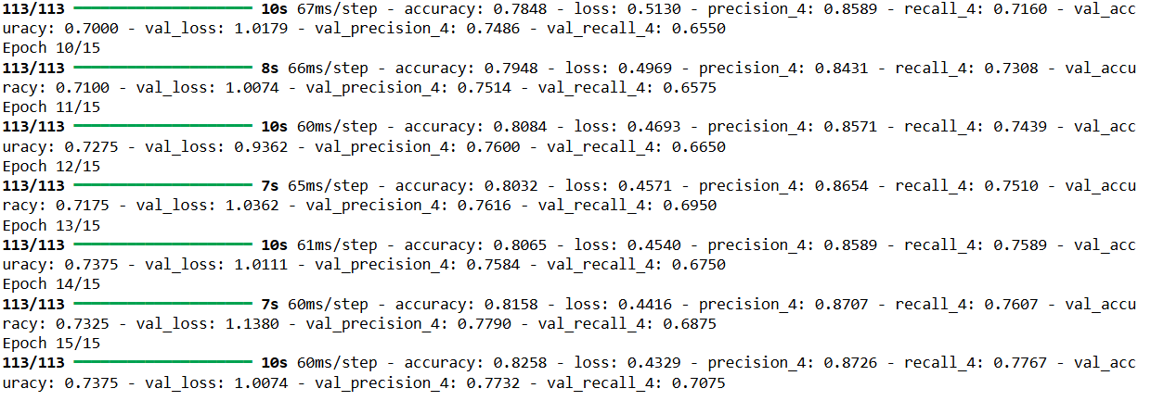

FINAL ACCURACY IN SGD OPTIMIZER:
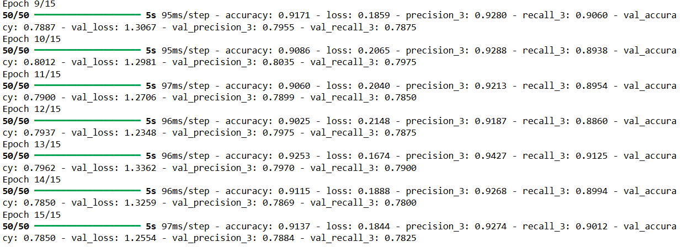
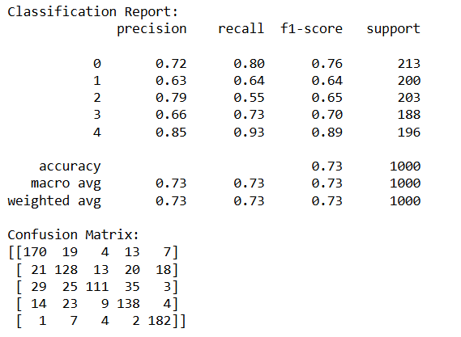

6.Conclusion:

In this study, we demonstrated the effectiveness of Artificial Intelligence and Machine Learning techniques in the automated detection of Diabetic Retinopathy (DR) from retinal images. By employing Convolutional Neural Networks (CNNs) for deep learning and comparing them with traditional machine learning algorithms such as Random Forest and Support Vector Machines (SVM), we established that deep learning models offer superior performance in terms of accuracy, precision, recall, and AUC-ROC.

Our preprocessing techniques—including image resizing, contrast enhancement, and data augmentation—contributed significantly to model robustness and generalization. The findings suggest that AI-driven diagnostic systems have great potential to support early detection and timely treatment of DR, especially in under-resourced or remote areas where access to specialized healthcare is limited.

Overall, this research underscores the transformative role of AI and ML in medical diagnostics, paving the way for scalable, efficient, and reliable tools that can aid clinicians and improve patient outcomes.

Future Work:
- Early Detection and Predictive Models: Future research should focus on developing more accurate and scalable machine learning and AI-based models that can predict DR at an earlier stage, using multimodal data such as fundus images, OCT scans, and patient health records.
- Integration of Multi-Omics Data: Incorporating genomics, proteomics, and metabolomics data can provide deeper insights into the molecular mechanisms driving DR, enabling personalized treatment approaches.
- Advanced Imaging Techniques: Continued development and refinement of imaging tools, like optical coherence tomography angiography (OCTA), can improve the detection of subtle vascular changes and provide better disease monitoring.
- Therapeutic Target Discovery: Identifying and validating novel therapeutic targets beyond VEGF, including anti-inflammatory and neuroprotective agents, could open new avenues for DR treatment, particularly in patients unresponsive to current therapies.
- Understanding Disease Heterogeneity: Future studies should aim to characterize different DR phenotypes and their progression patterns to tailor interventions more effectively.
- Real-World Clinical Applications: Translating research advancements into user-friendly diagnostic tools and treatment strategies suitable for routine clinical use, especially in low-resource settings, remains a crucial goal.
- Patient-Centric Approaches: Incorporating patient-reported outcomes and quality of life metrics into DR research can guide the development of more holistic and effective care strategies.

7.References:
  - Kashani, A. H., Chen, C. L., Gahm, J. K., Zheng, F., Richter, G. M., Rosenfeld, P. J., ... & Wang, R. K. (2017). Optical coherence tomography angiography: A comprehensive review of current methods and clinical applications. Progress in Retinal and Eye Research, 60, 66–100. https://doi.org/10.1016/j.preteyeres.2017.07.002

  - Klaassen, I., Van Noorden, C. J., & Schlingemann, R. O. (2013). Molecular basis of the inner blood-retinal barrier and its breakdown in diabetic macular edema and other pathological conditions. Progress in Retinal and Eye Research, 34, 19–48. https://doi.org/10.1016/j.preteyeres.2013.02.001

  - Kur, J., Newman, E. A., & Chan-Ling, T. (2012). Cellular and physiological mechanisms underlying blood flow regulation in the retina and choroid in health and disease. Progress in Retinal and Eye Research, 31(5), 377–406. https://doi.org/10.1016/j.preteyeres.2012.04.004

  - Penn, J. S., Madan, A., Caldwell, R. B., Bartoli, M., Caldwell, R. W., & Hartnett, M. E. (2008). Vascular endothelial growth factor in eye disease. Progress in Retinal and Eye Research, 27(4), 331–371. https://doi.org/10.1016/j.preteyeres.2008.05.001

  - Spaide, R. F., Klancnik Jr, J. M., & Cooney, M. J. (2017). Retinal vascular layers imaged by fluorescein angiography and optical coherence tomography angiography. JAMA Ophthalmology, 133(1), 45–50. https://doi.org/10.1001/jamaophthalmol.2014.3616

  - Stitt, A. W., Curtis, T. M., Chen, M., Medina, R. J., McKay, G. J., Jenkins, A., ... & Gardiner, T. A. (2015). The progress in understanding and treatment of diabetic retinopathy. Progress in Retinal and Eye Research, 51, 156–186. https://doi.org/10.1016/j.preteyeres.2015.08.001

  - Tang, J., & Kern, T. S. (2011). Inflammation in diabetic retinopathy. Progress in Retinal and Eye Research, 30(5), 343–358. https://doi.org/10.1016/j.preteyeres.2011.05.002

